Code snippets for DHI.Generic.NetCDF.MIKE (C#)

To start using "DHI.Generic.NetCDF.MIKE" as part of a .NET project, you have to reference the "DHI.Generic.NetCDF.MIKE.exe" file in .NET project.

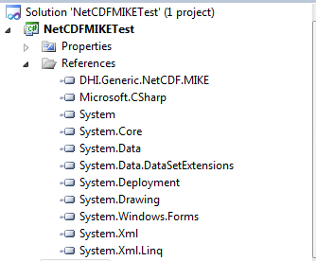

On top of that, you have to add the following code snippets to any classes that use this library.

using DHI.Generic.NetCDF.MIKE;

using DHI.Generic.NetCDF.MIKE.Commands;

# Creating a new "Engine Settings" object

The first step to using this library is to create a new "Engine Settings" object, use the following code snippets to start.

EngineSettings newEngineSettings = new EngineSettings();

newEngineSettings.Commands = new List<CommandSettings>();

CommandSettings newCommand = new CommandSettings();

Note: A list of commands can be found under DHI.Generic.NetCDF.MIKE.Commands, as shown below.

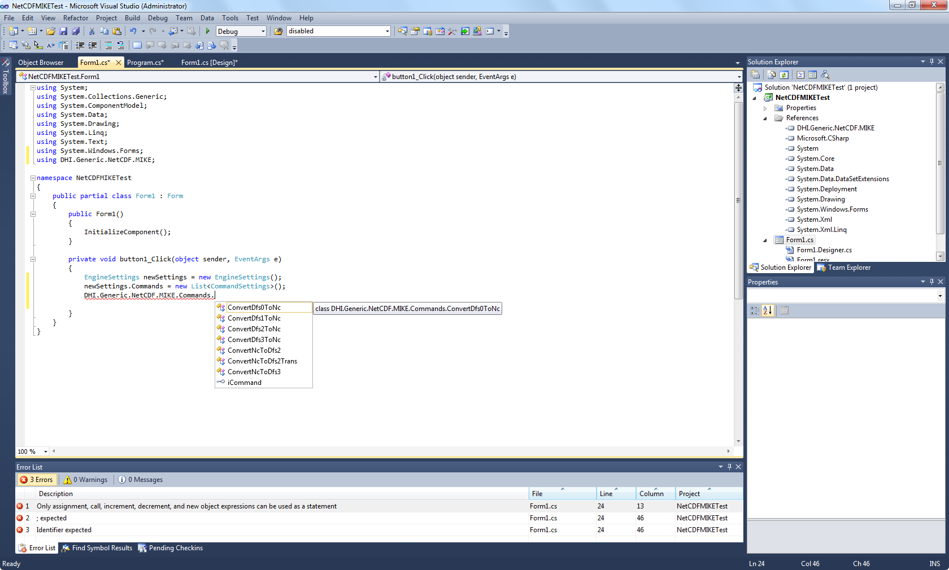

# Deserialising an Engine Settings file from xml file

Alternatively you can choose to import an existing xml settings file into an object. To do that you will first need to generate a settings file using "DHI.Generic.NetCDF.MIKE". Start the program and go through the interface to select the command and desired settings from Step 1 to Step 5 and then click "Export Settings" at Step 5.

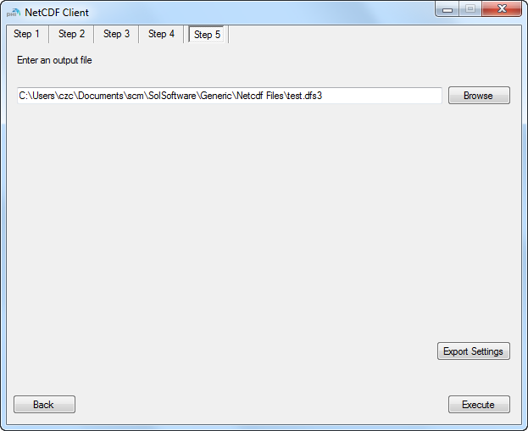

Once you have an existing settings file, use the following code snippets to deserialise the file into an object.

XmlSerialiser xmlSerialiser = new XmlSerialiser();

string xmlData = xmlSerialiser.ReadXMLFile(*"existingSettingsFile.xml"*);

EngineSettings newEngineSettings = new EngineSettings();

newEngineSettings = (EngineSettings)xmlSerialiser.DeserializeObject(xmlData, typeof(EngineSettings));

# Creating and running a new Command Engine

Once you have an "EngineSettings" object, you should proceed to create a "Command Engine" object before you can run the specific command. To do so, use the following code snippets.

CommandEngine newEngine = new CommandEngine();

newEngine.InitEngine(newEngineSettings);

newEngine.AutoRun();

# Anatomy of Engine Settings

The "Engine Settings" object stores all the information needed to convert a DFS file to NC file and vice versa. The same object is used for all the commands in this library but some attributes only apply to certain commands. The following is an example from "ConvertNcToDfs3" command.

<?xml version="1.0" encoding="utf-8"?>

<EngineSettings xmlns:xsi="http://www.w3.org/2001/XMLSchema-instance" xmlns:xsd="http://www.w3.org/2001/XMLSchema">

This section is for batch processing. The "InputFilePrefix" will allow the program to know which files to be selected for batch processing. In this example, all the files which start with "101101_S" and have an extension of ".nc" in the folder "C:\" will be processed. The output files will have a prefix of "_20140905".

E.g. 101101_S_1.nc will be converted to 101101_S_1_20140905.dfs3 and so on.

Note: if you are not using batch processing, then ignore these attributes.

<InputFilePrefix>101101_S</InputFilePrefix>

<InputFileExtension>.nc</InputFileExtension>

<OutputFilePrefix>_20140905</OutputFilePrefix>

<WorkingDirectory>C:\</WorkingDirectory>

<Commands>

This section is for storing the information for each command. You can have multiple commands in an EngineSettings object. Most of these settings are self-explanatory and are obtained through the user interface of "DHI.Generic.NetCDF.MIKE.exe" from steps 1 to 5.

The only exceptions are:

- UseDataSet, this is normally set to false for faster processing. You can set it to true if you are reading a netcdf file directly from an OPeNDAB source. (<http://en.wikipedia.org/wiki/OPeNDAP>)

- EUMItemKey and EUMItemUnitKey, these are unique keys used by the DFS files or by the CF standard convention. To get a complete list of the EUM keys for DFS files, please refer to DHI.Generic.MikeZero.DFS library. To get a complete list of the EUM keys from the CF standard convention, please go to <http://cfconventions.org/>

<CommandSettings>

<CommandName>ConvertNcToDfs3</CommandName>

<UseDataSet>false</UseDataSet>

<InputFileName>C:\101101_S.nc</InputFileName>

<InputFileExtension>.nc</InputFileExtension>

<OutputFileName>C:\test.dfs3</OutputFileName>

<OutputFileExtension>.dfs3</OutputFileExtension>

<MaxBlockSizeMB>10</MaxBlockSizeMB>

<Variables>

<string>vosaline</string>

</Variables>

<VariablesMappings>

<DHICFEntry>

<EUMItemKey>100149</EUMItemKey>

<EUMMappedItemUnitKey>2603</EUMMappedItemUnitKey>

<EUMItemDesc>1st order rate AD model</EUMItemDesc>

<EUMMappedItemUnitDesc>per hour</EUMMappedItemUnitDesc>

<EUMItemUnitDesc>

<string>per hour</string>

</EUMItemUnitDesc>

<EUMItemUnitKeys>

<int>2603</int>

</EUMItemUnitKeys>

</DHICFEntry>

<DHICFEntry>

<EUMItemKey>0</EUMItemKey>

<EUMMappedItemUnitKey>0</EUMMappedItemUnitKey>

</DHICFEntry>

<DHICFEntry>

<EUMItemKey>0</EUMItemKey>

<EUMMappedItemUnitKey>0</EUMMappedItemUnitKey>

</DHICFEntry>

<DHICFEntry>

<EUMItemKey>0</EUMItemKey>

<EUMMappedItemUnitKey>0</EUMMappedItemUnitKey>

</DHICFEntry>

<DHICFEntry>

<EUMItemKey>0</EUMItemKey>

<EUMMappedItemUnitKey>0</EUMMappedItemUnitKey>

</DHICFEntry>

<DHICFEntry>

<EUMItemKey>0</EUMItemKey>

<EUMMappedItemUnitKey>0</EUMMappedItemUnitKey>

</DHICFEntry>

</VariablesMappings>

<IsVariablesSelected>

<boolean>true</boolean>

</IsVariablesSelected>

<XAxisName>lon</XAxisName>

<XAxisDimensionName>lon</XAxisDimensionName>

<XLayer>0:676</XLayer>

<OverwriteOriginX>-999</OverwriteOriginX>

<OverwriteOriginY>-999</OverwriteOriginY>

<OverwriteRotation>-999</OverwriteRotation>

<YAxisName>lat</YAxisName>

<YAxisDimensionName>lat</YAxisDimensionName>

<YLayer>0:252</YLayer>

<ZAxisName>depth</ZAxisName>

<ZAxisDimensionName>depth</ZAxisDimensionName>

<ZLayer>0</ZLayer>

<TimeAxisName>time</TimeAxisName>

<TimeAxisDimensionName>time</TimeAxisDimensionName>

<TimeLayer>0</TimeLayer>

<DZ>0</DZ>

<MZMapProjectionString>LONG/LAT</MZMapProjectionString>

<ProjectionEastNorthMultiplier />

<TransectSpaceStepsNumber>10</TransectSpaceStepsNumber>

<TimeStepSeconds>86400</TimeStepSeconds>

<NumberXCells>0</NumberXCells>

<NumberYCells>0</NumberYCells>

<NumberZCells>0</NumberZCells>

<DX>0</DX>

<DY>0</DY>

</CommandSettings>

</Commands>

</EngineSettings>